**Technical Note**

This technical note presents the methodological procedures for calculating origin-destination (OD) matrices considering the road network in Morocco. Also, changes in the OD matrix due to investments related to the Tiznit-Dakhla expressway project are evaluated. All files cited in this technical note are available on <https://github.com/aderocha-github/morocco_road>.

**1. Morocco Regions**

Fig. 1 shows the provincial boundaries of Morocco (level 72). These provinces are part of a regional administrative division (level 12). Table 1 shows an overlay of these regional classification levels.

**Fig. 1. Marocco Regions**

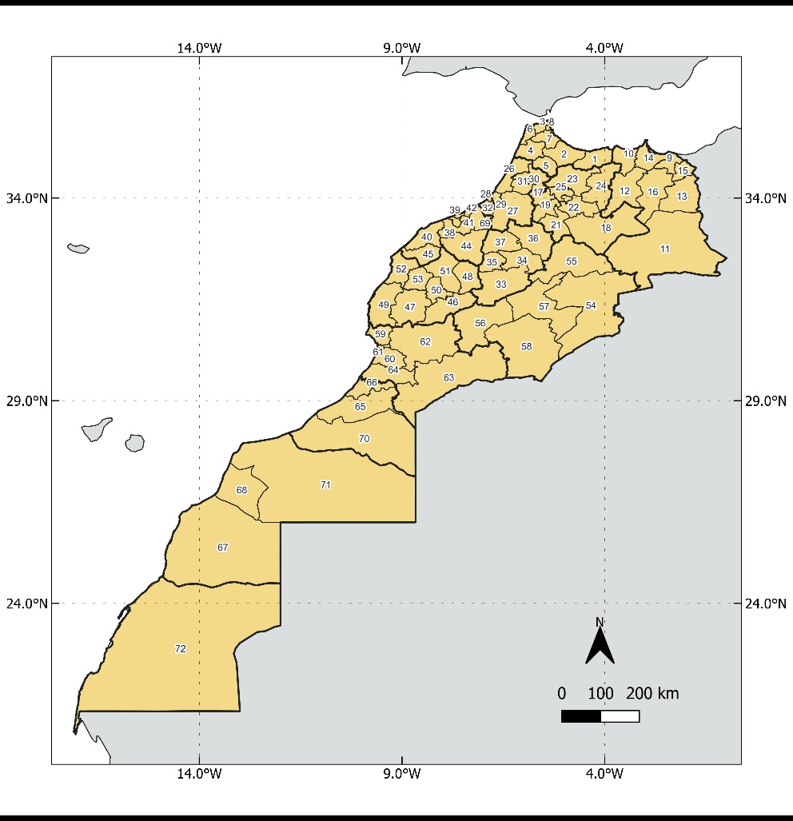

**Table 1. Marocco Regions (List)**

|  |  |  |  |
| --- | --- | --- | --- |
| *Id* | *Region (Level-12)* | *Id* | *Province (Level-72)* |
| 1 | Tanger-Tetouan-Al Hoceima | 1 | Al Hoceïma |
| 1 | Tanger-Tetouan-Al Hoceima | 2 | Chefchaouen |
| 1 | Tanger-Tetouan-Al Hoceima | 3 | Fahs-Anjra |
| 1 | Tanger-Tetouan-Al Hoceima | 4 | Larache |
| 1 | Tanger-Tetouan-Al Hoceima | 5 | Ouezzane |
| 1 | Tanger-Tetouan-Al Hoceima | 6 | Tanger-Assilah |
| 1 | Tanger-Tetouan-Al Hoceima | 7 | Tétouan |
| 1 | Tanger-Tetouan-Al Hoceima | 8 | M'Diq-Fnideq |
| 2 | Oriental | 9 | Berkane |
| 2 | Oriental | 10 | Driouch |
| 2 | Oriental | 11 | Figuig |
| 2 | Oriental | 12 | Guercif |
| 2 | Oriental | 13 | Jerada |
| 2 | Oriental | 14 | Nador |
| 2 | Oriental | 15 | Oujda-Angad |
| 2 | Oriental | 16 | Taourirt |
| 3 | Fes-Meknes | 17 | Meknès |
| 3 | Fes-Meknes | 18 | Boulemane |
| 3 | Fes-Meknes | 19 | El Hajeb |
| 3 | Fes-Meknes | 20 | Fès |
| 3 | Fes-Meknes | 21 | Ifrane |
| 3 | Fes-Meknes | 22 | Sefrou |
| 3 | Fes-Meknes | 23 | Taounate |
| 3 | Fes-Meknes | 24 | Taza |
| 3 | Fes-Meknes | 25 | Moulay Yacoub |
| 4 | Rabat-Sale-Kenitra | 26 | Kénitra |
| 4 | Rabat-Sale-Kenitra | 27 | Khémisset |
| 4 | Rabat-Sale-Kenitra | 28 | Rabat |
| 4 | Rabat-Sale-Kenitra | 29 | Salé |
| 4 | Rabat-Sale-Kenitra | 30 | Sidi Kacem |
| 4 | Rabat-Sale-Kenitra | 31 | Sidi Slimane |
| 4 | Rabat-Sale-Kenitra | 32 | Skhirate-Témara |
| 5 | Beni Mellal-Khenifra | 33 | Azilal |
| 5 | Beni Mellal-Khenifra | 34 | Béni Mellal |
| 5 | Beni Mellal-Khenifra | 35 | Fquih Ben Salah |
| 5 | Beni Mellal-Khenifra | 36 | Khénifra |
| 5 | Beni Mellal-Khenifra | 37 | Khouribga |
| 6 | Casablanca-Settat | 38 | Benslimane |
| 6 | Casablanca-Settat | 39 | Berrechid |
| 6 | Casablanca-Settat | 40 | Casablanca |
| 6 | Casablanca-Settat | 41 | El Jadida |
| 6 | Casablanca-Settat | 42 | Médiouna |
| 6 | Casablanca-Settat | 43 | Mohammadia |
| 6 | Casablanca-Settat | 44 | Nouaceur |
| 6 | Casablanca-Settat | 45 | Settat |
| 6 | Casablanca-Settat | 46 | Sidi Bennour |
| 7 | Marrakech-Safi | 47 | Al Haouz |
| 7 | Marrakech-Safi | 48 | Chichaoua |
| 7 | Marrakech-Safi | 49 | El Kelâa des Sraghna |
| 7 | Marrakech-Safi | 50 | Essaouira |
| 7 | Marrakech-Safi | 51 | Marrakech |
| 7 | Marrakech-Safi | 52 | Rehamna |
| 7 | Marrakech-Safi | 53 | Safi |
| 7 | Marrakech-Safi | 54 | Youssoufia |
| 8 | Draa-Tafilalet | 55 | Errachidia |
| 8 | Draa-Tafilalet | 56 | Midelt |
| 8 | Draa-Tafilalet | 57 | Ouarzazate |
| 8 | Draa-Tafilalet | 58 | Tinghir |
| 8 | Draa-Tafilalet | 59 | Zagora |
| 9 | Souss-Massa | 60 | Agadir-Ida-Ou-Tanane |
| 9 | Souss-Massa | 61 | Chtouka-Ait Baha |
| 9 | Souss-Massa | 62 | Inezgane-Ait Melloul |
| 9 | Souss-Massa | 63 | Taroudannt |
| 9 | Souss-Massa | 64 | Tata |
| 9 | Souss-Massa | 65 | Tiznit |
| 10 | Guelmim-Oued Noun | 66 | Guelmim |
| 10 | Guelmim-Oued Noun | 67 | Sidi Ifni |
| 10 | Guelmim-Oued Noun | 68 | Tan-Tan / Assa-Zag |
| 11 | Laayoune-Sakia El Hamra | 69 | Boujdour |
| 11 | Laayoune-Sakia El Hamra | 70 | Laâyoune |
| 11 | Laayoune-Sakia El Hamra | 71 | Es-Semara / Tarfaya |
| 12 | Dakhla-Oued Ed Dahab | 72 | Oued Ed Dahab / Aousserd |

**2. Network Nodes**

The network node shapefile for the Morocco regions (level-72) were created from the lists of coordinates recorded in Table 2. Latitude and longitude values are from the Nominatim website ([https://nominatim.openstreetmap.org/](https://nominatim.openstreetmap.org/ui/search.html?city=)). In this case, we use an R code that automates the search for the name of the regional capitals and saves the coordinate data.

**Table 2. Marocco Regions (Coordinates)**

|  |  |  |  |
| --- | --- | --- | --- |
| *Id* | *Province (Level-72)* | *Latitude* | *Longitude* |
| 1 | Al Hoceïma | 35.25 | -3.93 |
| 2 | Chefchaouen | 35.17 | -5.28 |
| 3 | Fahs-Anjra | 35.76 | -5.65 |
| 4 | Larache | 35.20 | -6.15 |
| 5 | Ouezzane | 35.17 | -5.26 |
| 6 | Tanger-Assilah | 35.78 | -5.80 |
| 7 | Tétouan | 35.57 | -5.37 |
| 8 | M'Diq-Fnideq | 35.68 | -5.32 |
| 9 | Berkane | 34.93 | -2.33 |
| 10 | Driouch | 34.98 | -3.39 |
| 11 | Figuig | 32.71 | -2.63 |
| 12 | Guercif | 34.23 | -3.35 |
| 13 | Jerada | 34.31 | -2.16 |
| 14 | Nador | 35.21 | -2.91 |
| 15 | Oujda-Angad | 34.67 | -2.04 |
| 16 | Taourirt | 34.41 | -2.89 |
| 17 | Meknès | 33.90 | -5.53 |
| 18 | Boulemane | 33.36 | -4.73 |
| 19 | El Hajeb | 33.70 | -5.49 |
| 20 | Fès | 34.03 | -5.02 |
| 21 | Ifrane | 33.53 | -5.11 |
| 22 | Sefrou | 33.82 | -4.83 |
| 23 | Taounate | 34.54 | -4.64 |
| 24 | Taza | 34.23 | -4.01 |
| 25 | Moulay Yacoub | 34.09 | -5.18 |
| 26 | Kénitra | 34.26 | -6.57 |
| 27 | Khémisset | 33.83 | -6.07 |
| 28 | Rabat | 34.02 | -6.83 |
| 29 | Salé | 34.04 | -6.81 |
| 30 | Sidi Kacem | 34.23 | -5.71 |
| 31 | Sidi Slimane | 34.26 | -5.93 |
| 32 | Skhirate-Témara | 33.75 | -6.88 |
| 33 | Azilal | 31.87 | -6.43 |
| 34 | Béni Mellal | 32.33 | -6.35 |
| 35 | Fquih Ben Salah | 32.51 | -6.85 |
| 36 | Khénifra | 32.94 | -5.67 |
| 37 | Khouribga | 32.89 | -6.91 |
| 38 | Benslimane | 33.62 | -7.12 |
| 39 | Berrechid | 33.27 | -7.58 |
| 40 | Casablanca | 33.60 | -7.62 |
| 41 | El Jadida | 33.23 | -8.50 |
| 42 | Médiouna | 33.46 | -7.52 |
| 43 | Mohammadia | 33.70 | -7.39 |
| 44 | Nouaceur | 33.38 | -7.62 |
| 45 | Settat | 33.00 | -7.62 |
| 46 | Sidi Bennour | 32.65 | -8.42 |
| 47 | Al Haouz | 31.51 | -9.77 |
| 48 | Chichaoua | 31.55 | -8.76 |
| 49 | El Kelâa des Sraghna | 32.05 | -7.41 |
| 50 | Essaouira | 31.51 | -9.76 |
| 51 | Marrakech | 31.63 | -7.99 |
| 52 | Rehamna | 32.29 | -7.95 |
| 53 | Safi | 32.27 | -9.23 |
| 54 | Youssoufia | 32.25 | -8.53 |
| 55 | Errachidia | 31.93 | -4.43 |
| 56 | Midelt | 32.68 | -4.74 |
| 57 | Ouarzazate | 30.92 | -6.91 |
| 58 | Tinghir | 31.52 | -5.53 |
| 59 | Zagora | 30.33 | -5.84 |
| 60 | Agadir-Ida-Ou-Tanane | 30.42 | -9.60 |
| 61 | Chtouka-Ait Baha | 30.01 | -9.33 |
| 62 | Inezgane-Ait Melloul | 30.36 | -9.55 |
| 63 | Taroudannt | 30.47 | -8.87 |
| 64 | Tata | 29.75 | -7.97 |
| 65 | Tiznit | 29.70 | -9.73 |
| 66 | Guelmim | 28.99 | -10.06 |
| 67 | Sidi Ifni | 29.38 | -10.17 |
| 68 | Tan-Tan / Assa-Zag | 28.61 | -9.44 |
| 69 | Boujdour | 26.13 | -14.48 |
| 70 | Laâyoune | 27.16 | -13.20 |
| 71 | Es-Semara / Tarfaya | 27.94 | -12.92 |
| 72 | Oued Ed Dahab / Aousserd | 22.06 | -16.75 |

**3. GIS Road Network**

The road network data were taken from *OpenStreetMap* (<http://www.openstreetmap.org/>), a free and editable map built by volunteers and released with an open-content license. The data from *OpenStreetMap* were downloaded from Geofabrik’s free download server (<http://download.geofabrik.de/index.html>).

The road network in *OpenStreetMap* is classified by a tag named “highway” that is any road, route, way, or thoroughfare on land which connects one location to another and has been paved or otherwise improved to allow travel by some conveyance, including motorized vehicles, cyclists, pedestrians, horse riders, and others (but not trains). Table 3, extracted from <http://wiki.openstreetmap.org/wiki/Map_Features>, describes how *OpenStreetMap* classifies the road network.

We considered only the country’s main highways for this project, so we applied a filter and used the key “highway” classified as a motorway, motorway_link, trunk, trunk_link, primary, primary_link, secondary, secondary _link, tertiary, and tertiary_link (Table 4).

The geographic coordinate system used is the “Merchich_Sahara_Nord”. Using the Calculate Geometry tool from ArcGis, we created and calculated a new table field with the length of the roads. We also created a new table field of the free-flow average speed by road classification; for this, we used the conditions shown in Table 5.

With these two fields, we were able to create a new field that contains the time in minutes necessary to drive the whole road length, using the following formula:

*Time (Minutes) = Length (km)/Avg speed (km/h)*60.*

**Table 3. Main Tags for the Road Network**

|  |  |  |  |  |
| --- | --- | --- | --- | --- |
| ***Key*** | ***Value*** | ***Comment*** | ***Rendering*** | ***Photo*** |
| [highway](http://wiki.openstreetmap.org/wiki/Key:highway) | [motorway](http://wiki.openstreetmap.org/wiki/Tag:highway%3Dmotorway) | A restricted access major divided highway, normally with 2 or more running lanes plus emergency hard shoulder. Equivalent to the Freeway, Autobahn, etc.. | [Rendering-highway motorway neutral.png](http://wiki.openstreetmap.org/wiki/File:Rendering-highway_motorway_neutral.png) | [Motorway-photo.jpg](http://wiki.openstreetmap.org/wiki/File:Motorway-photo.jpg) |
| [highway](http://wiki.openstreetmap.org/wiki/Key:highway) | [trunk](http://wiki.openstreetmap.org/wiki/Tag:highway%3Dtrunk) | The most important roads in a country’s system that aren’t motorways. (Need not necessarily be a divided highway). | [Rendering-highway trunk L3005 MF.png](http://wiki.openstreetmap.org/wiki/File:Rendering-highway_trunk_L3005_MF.png) | [Dscf0444 600.jpg](http://wiki.openstreetmap.org/wiki/File:Dscf0444_600.jpg) |
| [highway](http://wiki.openstreetmap.org/wiki/Key:highway) | [primary](http://wiki.openstreetmap.org/wiki/Tag:highway%3Dprimary) | The next most important roads in a country’s system. (Often link larger towns). | [Rendering-highway primary neutral.png](http://wiki.openstreetmap.org/wiki/File:Rendering-highway_primary_neutral.png) | [Primary-photo.jpg](http://wiki.openstreetmap.org/wiki/File:Primary-photo.jpg) |
| [highway](http://wiki.openstreetmap.org/wiki/Key:highway) | [secondary](http://wiki.openstreetmap.org/wiki/Tag:highway%3Dsecondary) | The next most important roads in a country’s system. (Often link towns). | [Rendering-highway secondary neutral.png](http://wiki.openstreetmap.org/wiki/File:Rendering-highway_secondary_neutral.png) | [Meyenburg-L134.jpg](http://wiki.openstreetmap.org/wiki/File:Meyenburg-L134.jpg) |

|  |  |  |  |  |
| --- | --- | --- | --- | --- |
| [highway](http://wiki.openstreetmap.org/wiki/Key:highway) | [tertiary](http://wiki.openstreetmap.org/wiki/Tag:highway%3Dtertiary) | The next most important roads in a country’s system. (Often link smaller towns and villages). | [Rendering-highway tertiary neutral.png](http://wiki.openstreetmap.org/wiki/File:Rendering-highway_tertiary_neutral.png) | [OHZ-K28-Bergedorfer Str.jpg](http://wiki.openstreetmap.org/wiki/File:OHZ-K28-Bergedorfer_Str.jpg) |
| [highway](http://wiki.openstreetmap.org/wiki/Key:highway) | [unclassified](http://wiki.openstreetmap.org/wiki/Tag:highway%3Dunclassified) | The least most important through roads in a country’s system – i.e. minor roads of a lower classification than tertiary, but which serve a purpose other than access to properties. Often link villages and hamletes. (The word ‘unclassified’ is a historical artefact of the UK road system and does **not** mean that the classification is unknown; you can use [highway](http://wiki.openstreetmap.org/wiki/Key:highway)=[road](http://wiki.openstreetmap.org/wiki/Tag:highway%3Droad) for that). | [Rendering-highway unclassified.png](http://wiki.openstreetmap.org/wiki/File:Rendering-highway_unclassified.png) | [Highway unclassified-photo.jpg](http://wiki.openstreetmap.org/wiki/File:Highway_unclassified-photo.jpg) |
| [highway](http://wiki.openstreetmap.org/wiki/Key:highway) | [residential](http://wiki.openstreetmap.org/wiki/Tag:highway%3Dresidential) | Roads which serve as an access to housing, without function of connecting settlements. Often lined with housing. | [Rendering-highway residential.png](http://wiki.openstreetmap.org/wiki/File:Rendering-highway_residential.png) | [Residential.jpg](http://wiki.openstreetmap.org/wiki/File:Residential.jpg) |
| [highway](http://wiki.openstreetmap.org/wiki/Key:highway) | [service](http://wiki.openstreetmap.org/wiki/Tag:highway%3Dservice) | For access roads to, or within an industrial estate, camp site, business park, car park etc. Can be used in conjunction with [service](http://wiki.openstreetmap.org/wiki/Key:service)=* to indicate the type of usage and with [access](http://wiki.openstreetmap.org/wiki/Key:access)=* to indicate who can use it and in what circumstances. | [Rendering-highway service.png](http://wiki.openstreetmap.org/wiki/File:Rendering-highway_service.png) | [Alley.jpg](http://wiki.openstreetmap.org/wiki/File:Alley.jpg) |

**Table 4. Link Roads**

|  |  |  |  |  |
| --- | --- | --- | --- | --- |
| ***Key*** | ***Value*** | ***Comment*** | ***Rendering*** | ***Photo*** |
| [highway](http://wiki.openstreetmap.org/wiki/Key:highway) | [motorway_link](http://wiki.openstreetmap.org/wiki/Tag:highway%3Dmotorway_link) | The link roads (sliproads/ramps) leading to/from a motorway from/to a motorway or lower class highway. Generally with the same motorway restrictions. | [Rendering-highway motorway link.png](http://wiki.openstreetmap.org/wiki/File:Rendering-highway_motorway_link.png) | [Dscf0242 600.jpg](http://wiki.openstreetmap.org/wiki/File:Dscf0242_600.jpg) |
| [highway](http://wiki.openstreetmap.org/wiki/Key:highway) | [trunk_link](http://wiki.openstreetmap.org/wiki/Tag:highway%3Dtrunk_link) | The link roads (sliproads/ramps) leading to/from a trunk road from/to a trunk road or lower class highway. | [Rendering-highway trunk link.png](http://wiki.openstreetmap.org/wiki/File:Rendering-highway_trunk_link.png) | [Trunk link.jpg](http://wiki.openstreetmap.org/wiki/File:Trunk_link.jpg) |
| [highway](http://wiki.openstreetmap.org/wiki/Key:highway) | [primary_link](http://wiki.openstreetmap.org/wiki/Tag:highway%3Dprimary_link) | The link roads (sliproads/ramps) leading to/from a primary road from/to a primary road or lower class highway. | [Rendering-highway primary link.png](http://wiki.openstreetmap.org/wiki/File:Rendering-highway_primary_link.png) |  |
| [highway](http://wiki.openstreetmap.org/wiki/Key:highway) | [secondary_link](http://wiki.openstreetmap.org/wiki/Tag:highway%3Dsecondary_link) | The link roads (sliproads/ramps) leading to/from a secondary road from/to a secondary road or lower class highway. | same rendering as highway=secondary in mapnik |  |
| [highway](http://wiki.openstreetmap.org/wiki/Key:highway) | [tertiary_link](http://wiki.openstreetmap.org/wiki/Tag:highway%3Dtertiary_link) | The link roads (sliproads/ramps) leading to/from a tertiary road from/to a tertiary road or lower class highway. | same rendering as highway=tertiary in mapnik |  |

**Table 5. Average Free-Flow Speed by Road Type**

|  |  |
| --- | --- |
| ***Road type*** | ***Average speed (km/h)*** |
| motorway/motorway_link | 100 |
| trunk/trunk_link | 90 |
| primary/primary_link | 80 |
| secondary/secondary _link | 60 |
| tertiary/tertiary_link | 60 |

**4. Morocco OD Matrix Tutorial**

Step 1: To create the OD Matrix we need to open the shapefiles in ArcMap.

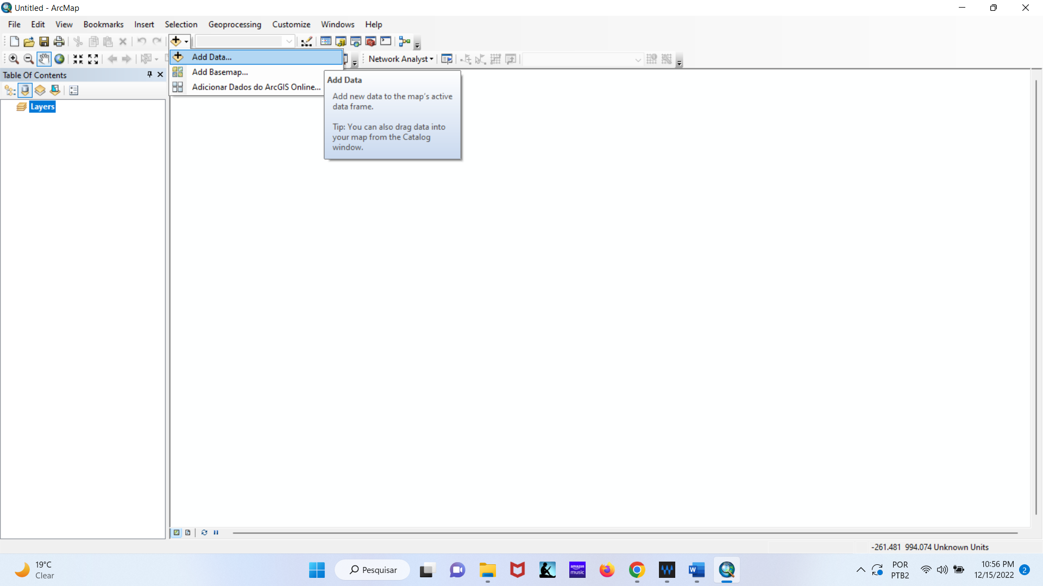

Select the layers indicated in the figure below.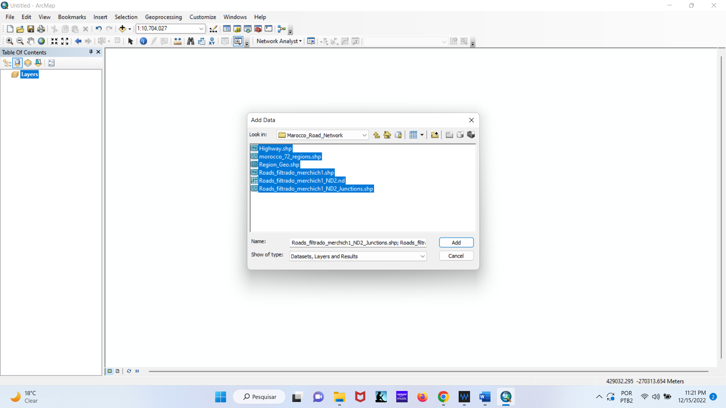

Confirm adding a network layer. 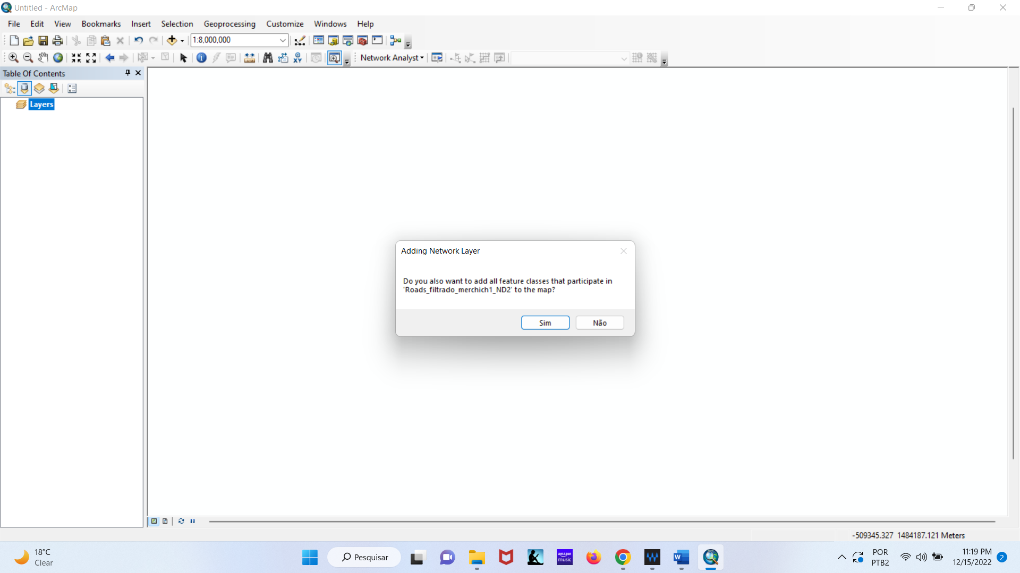

The road network can be visualized in the ArcMap.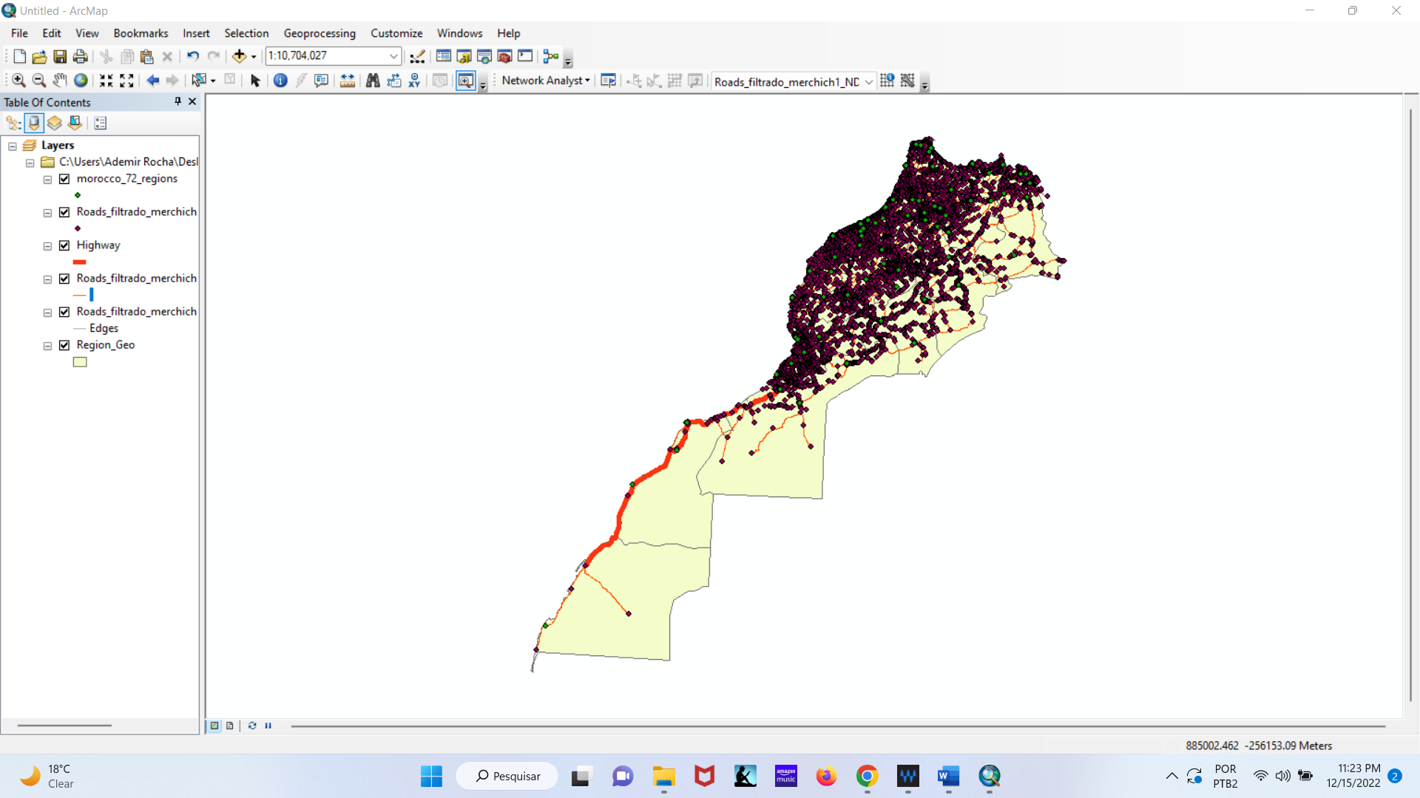

For a better visualization uncheck some layers as shown in the figure below.

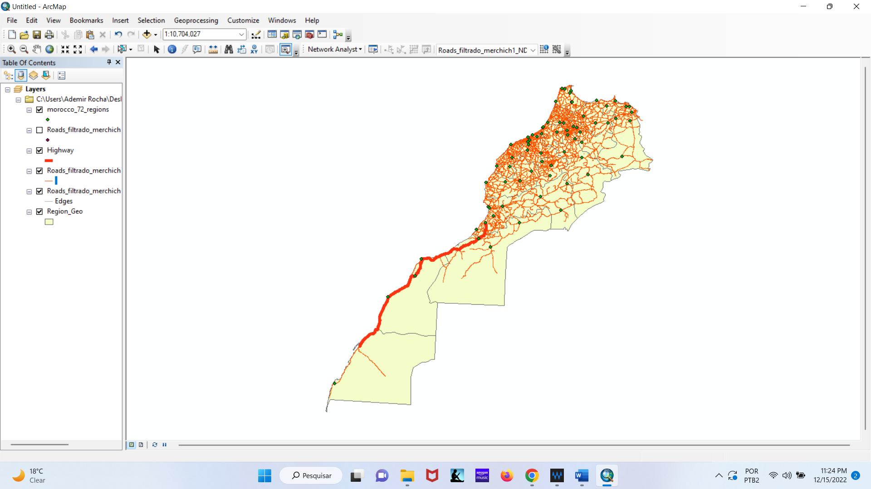

Step 2: Choose the New OD Matrix on Network Analyst tool (Extension for ArcGis).

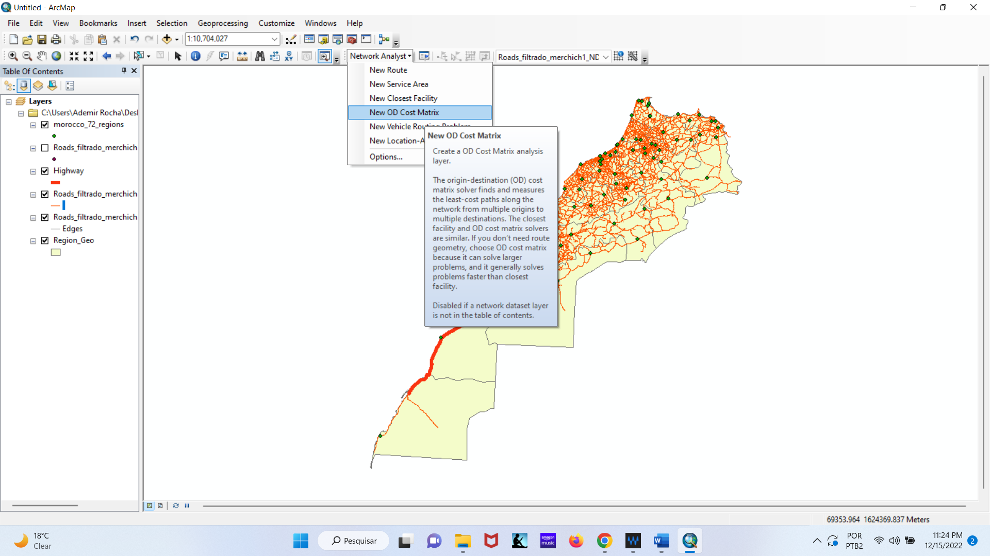

Step 3: When the Network Analyst window is not visible on the screen. Click on the Network Analyst window to show it on the screen.

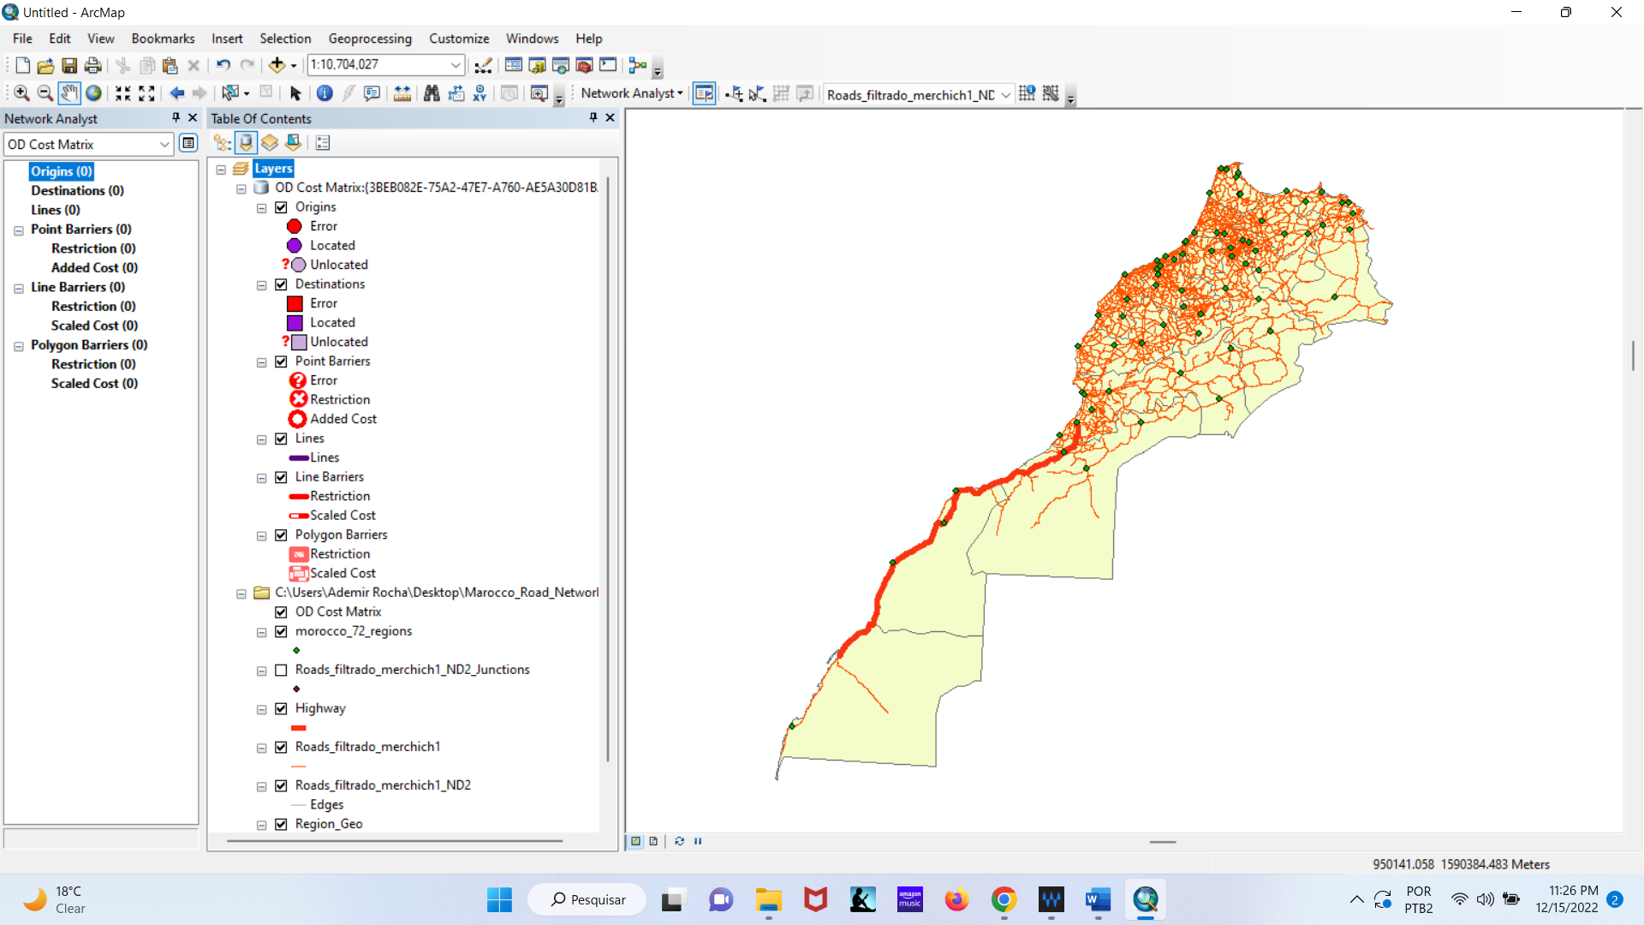

Step 4: With the right mouse button charge the Origins with the 72 provincial regions.

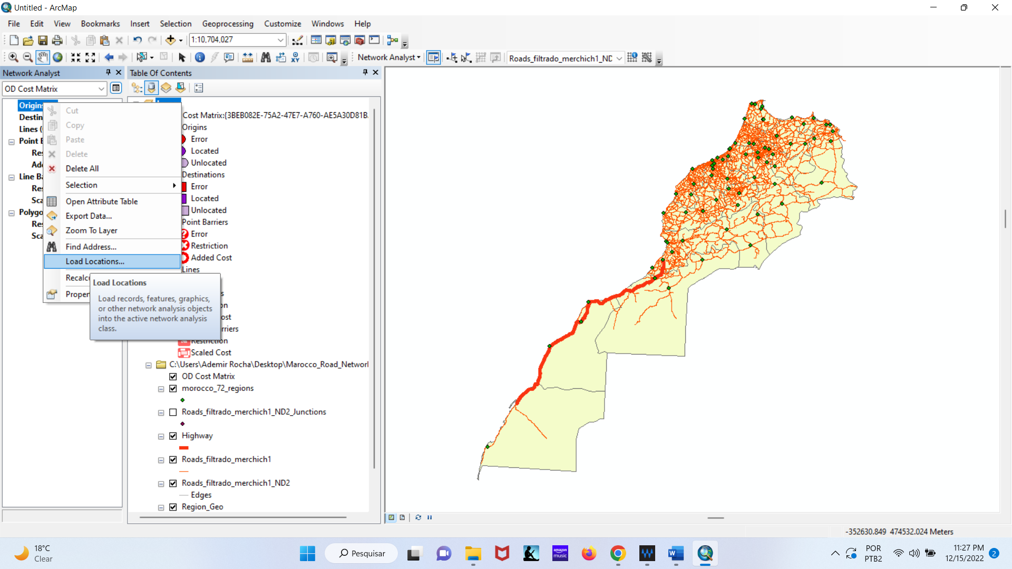

Pay attention for the parameters in the window on the figure below.

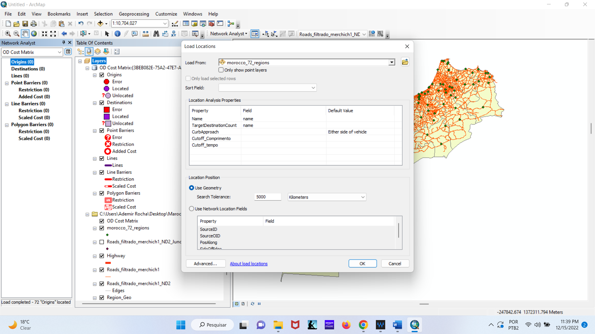

Note that after the process, some origin points were created (72 nodes).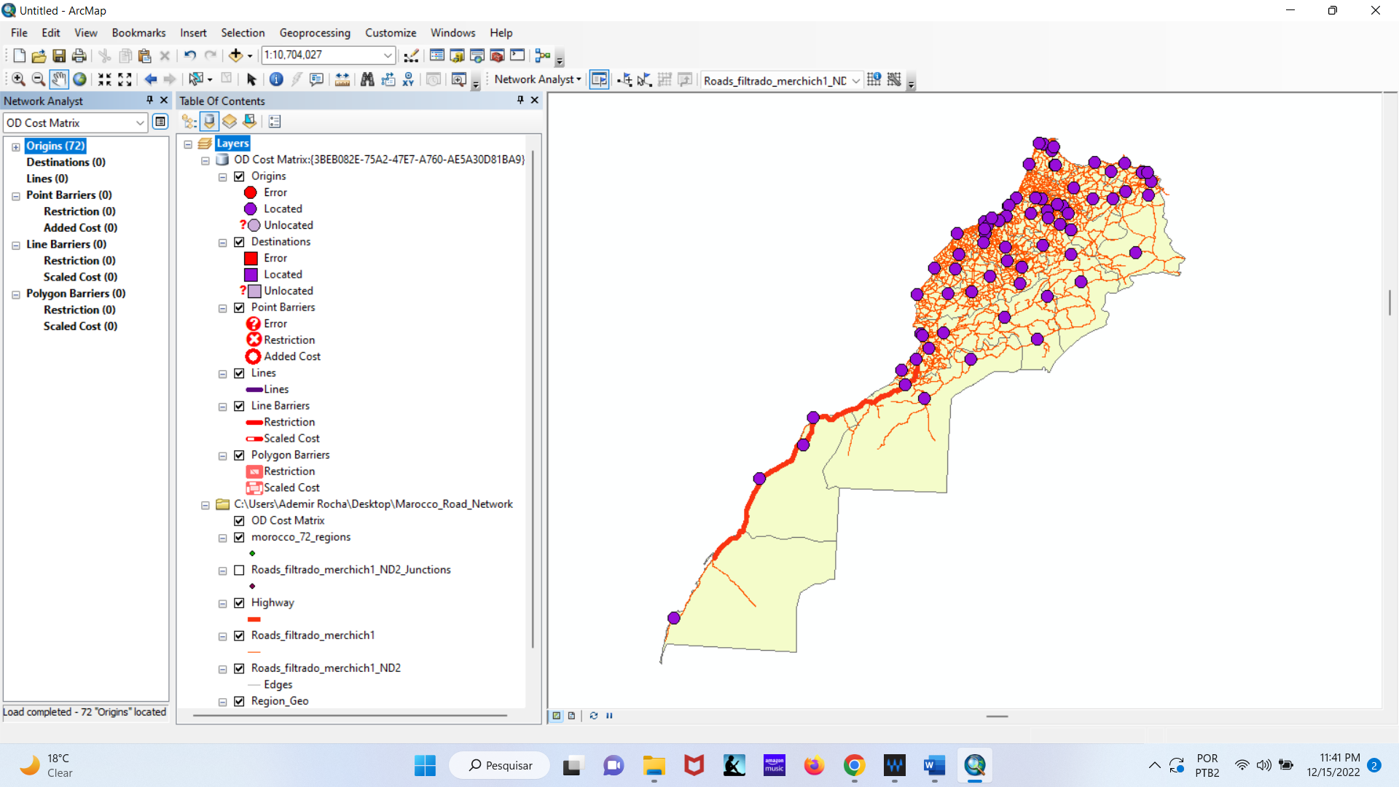

Step 5: Do the same for the Destination.

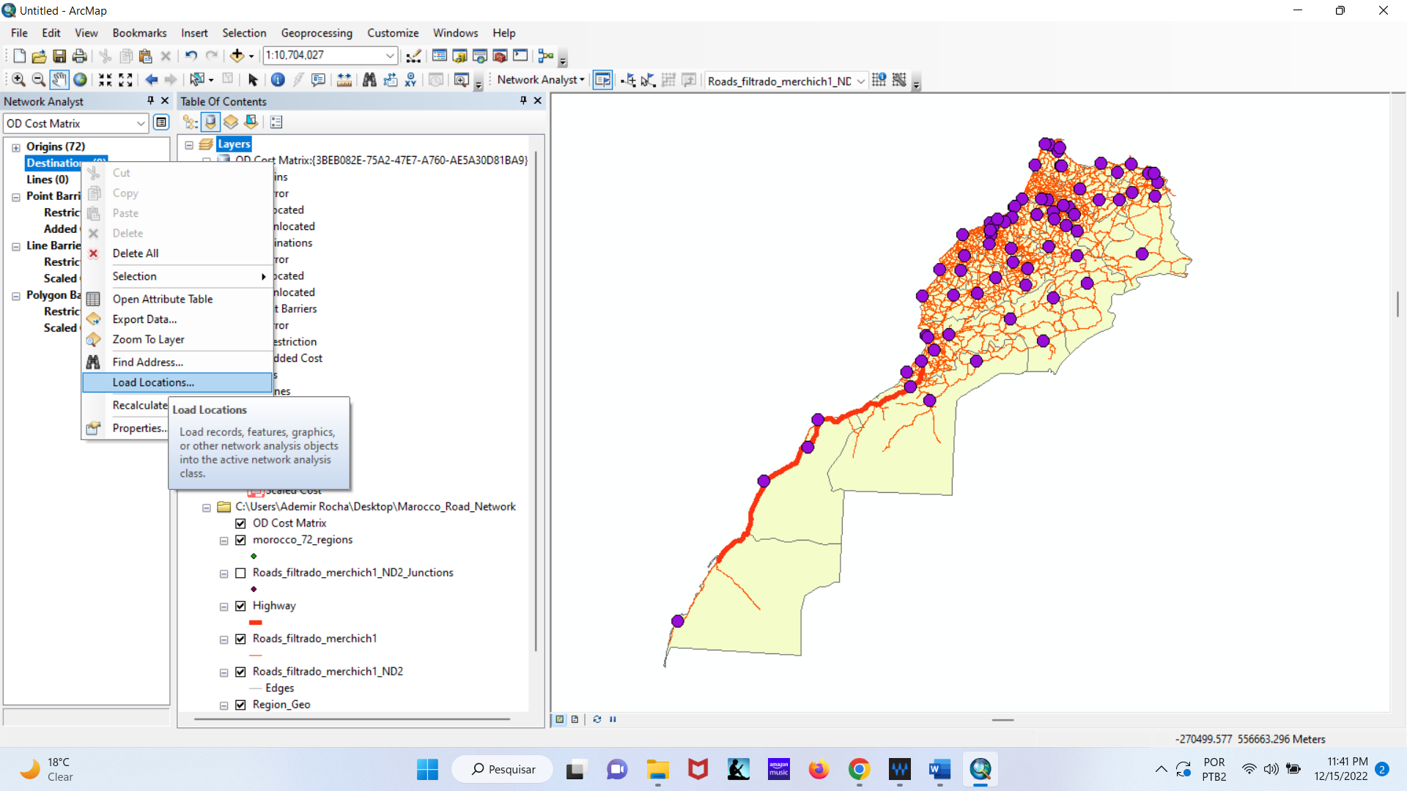

Pay attention for the parameters in the window on the figure below.

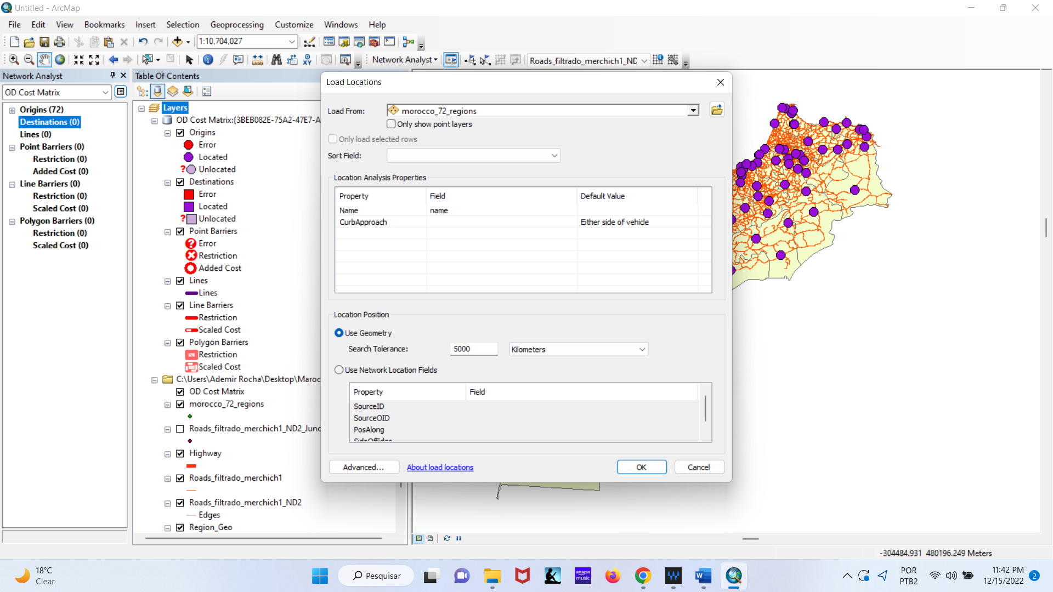

Note that after the process, some destination points were created (72 nodes). Check now if you have the 72 Origins and 72 Destinations.

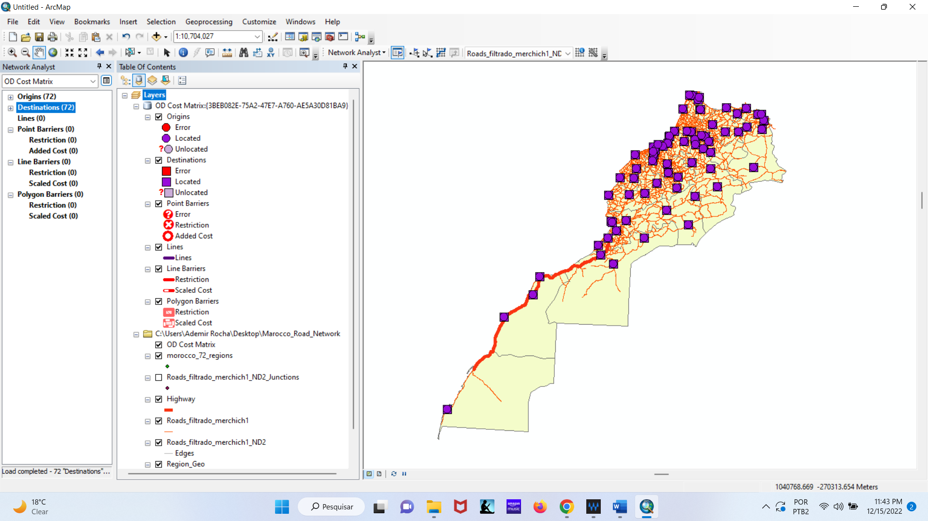

Step 6: Click on OD Matrix Properties. 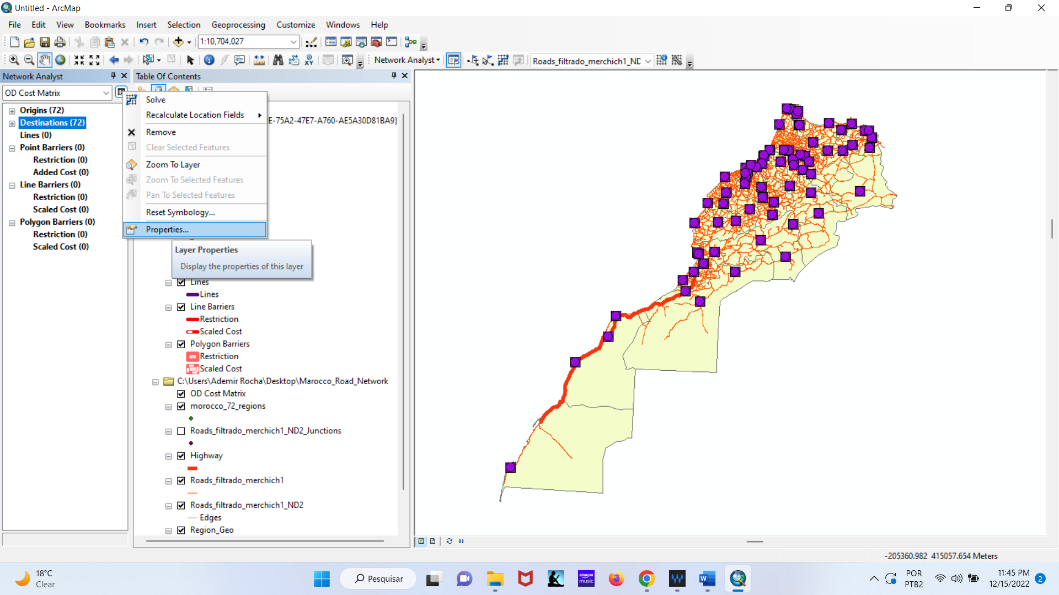

Use the length (kilometers) for Impedance.

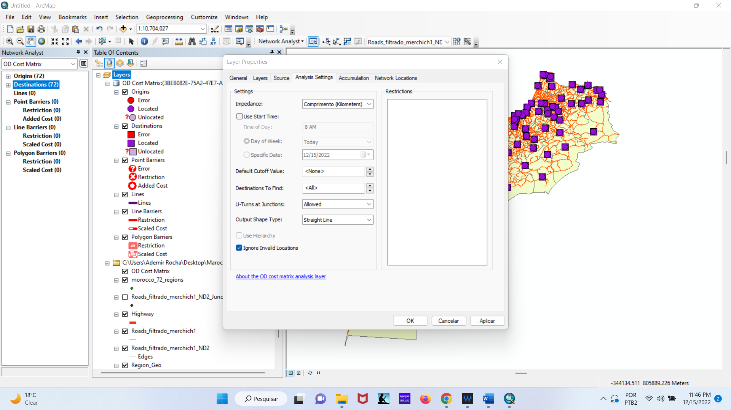

Check length and time to include in the table and then click OK.

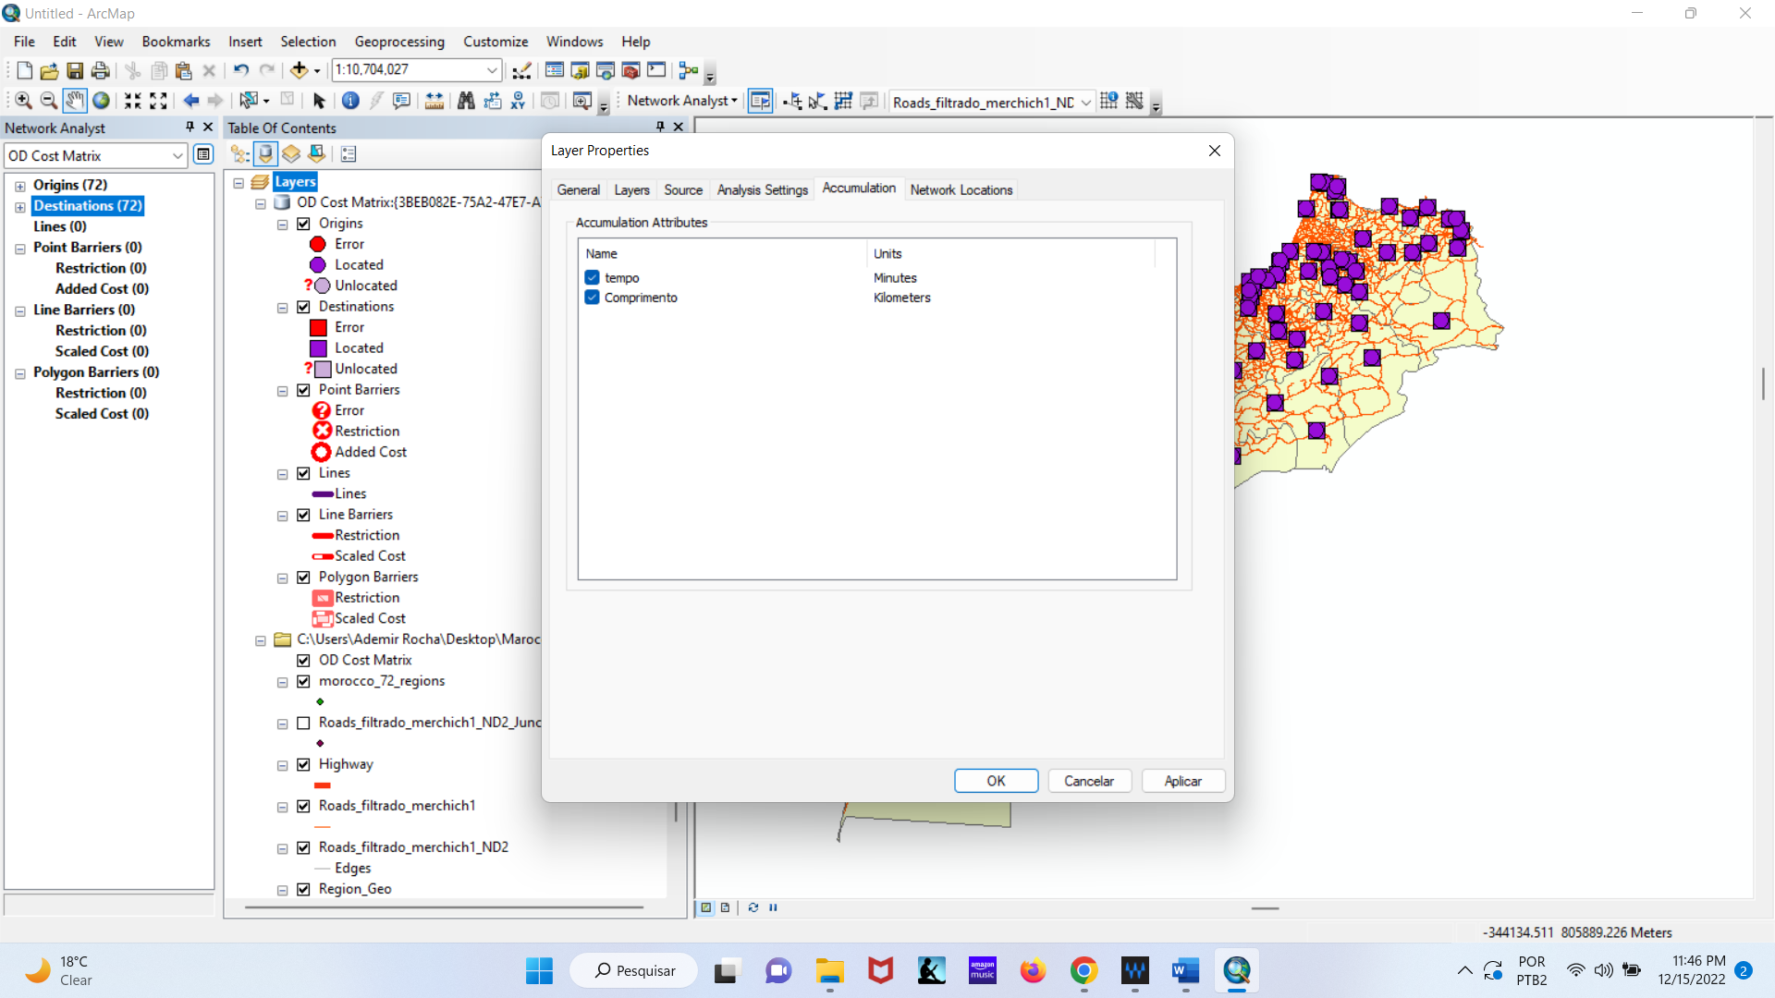

Step 7: On the Network Analyst click to Solve.

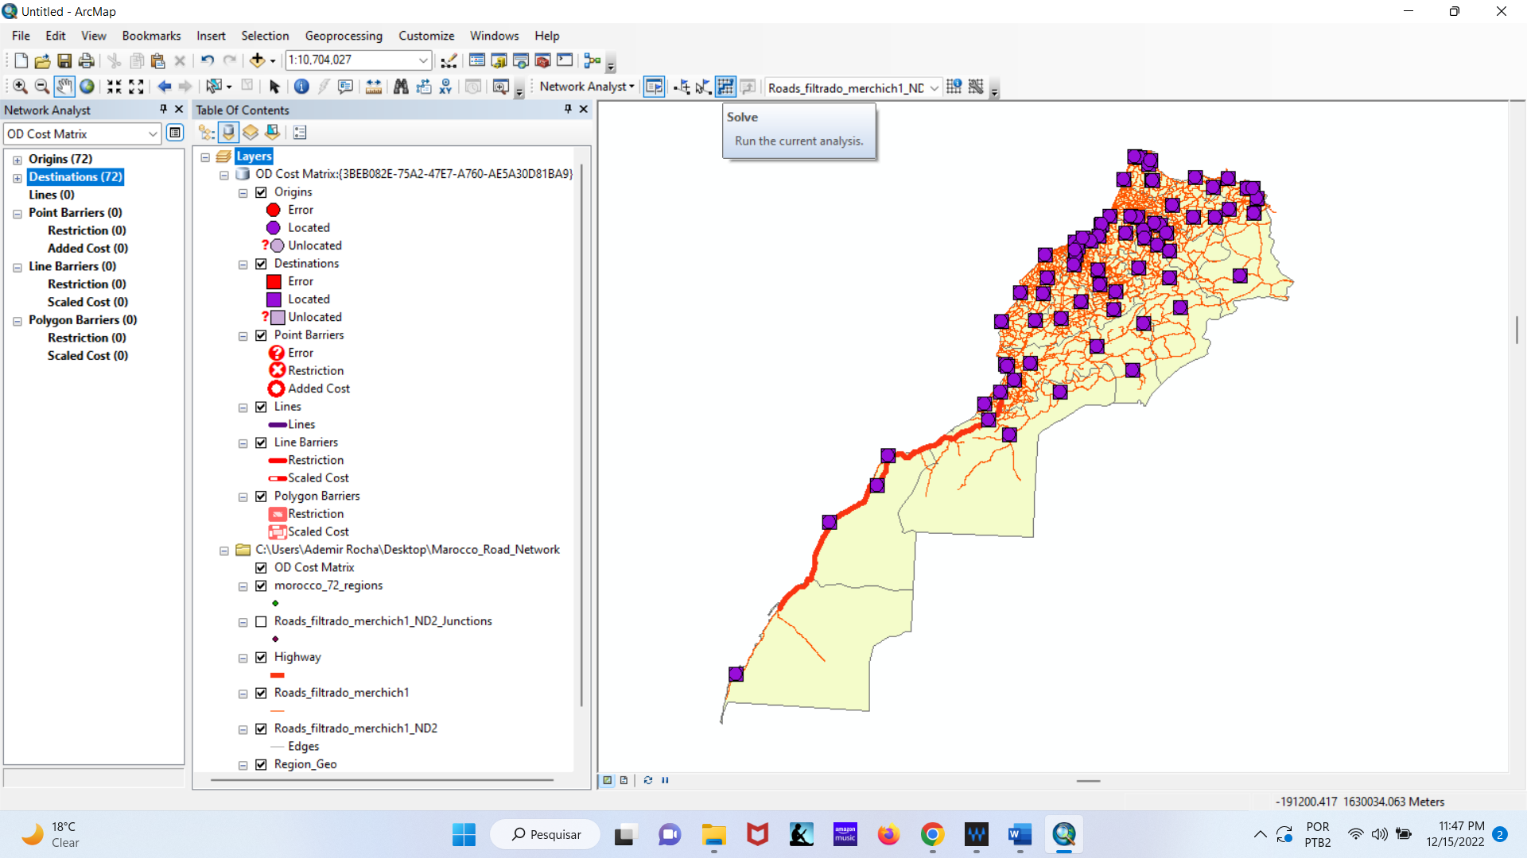

After solving will be create the lines that represent the travel between the cities (network edges).

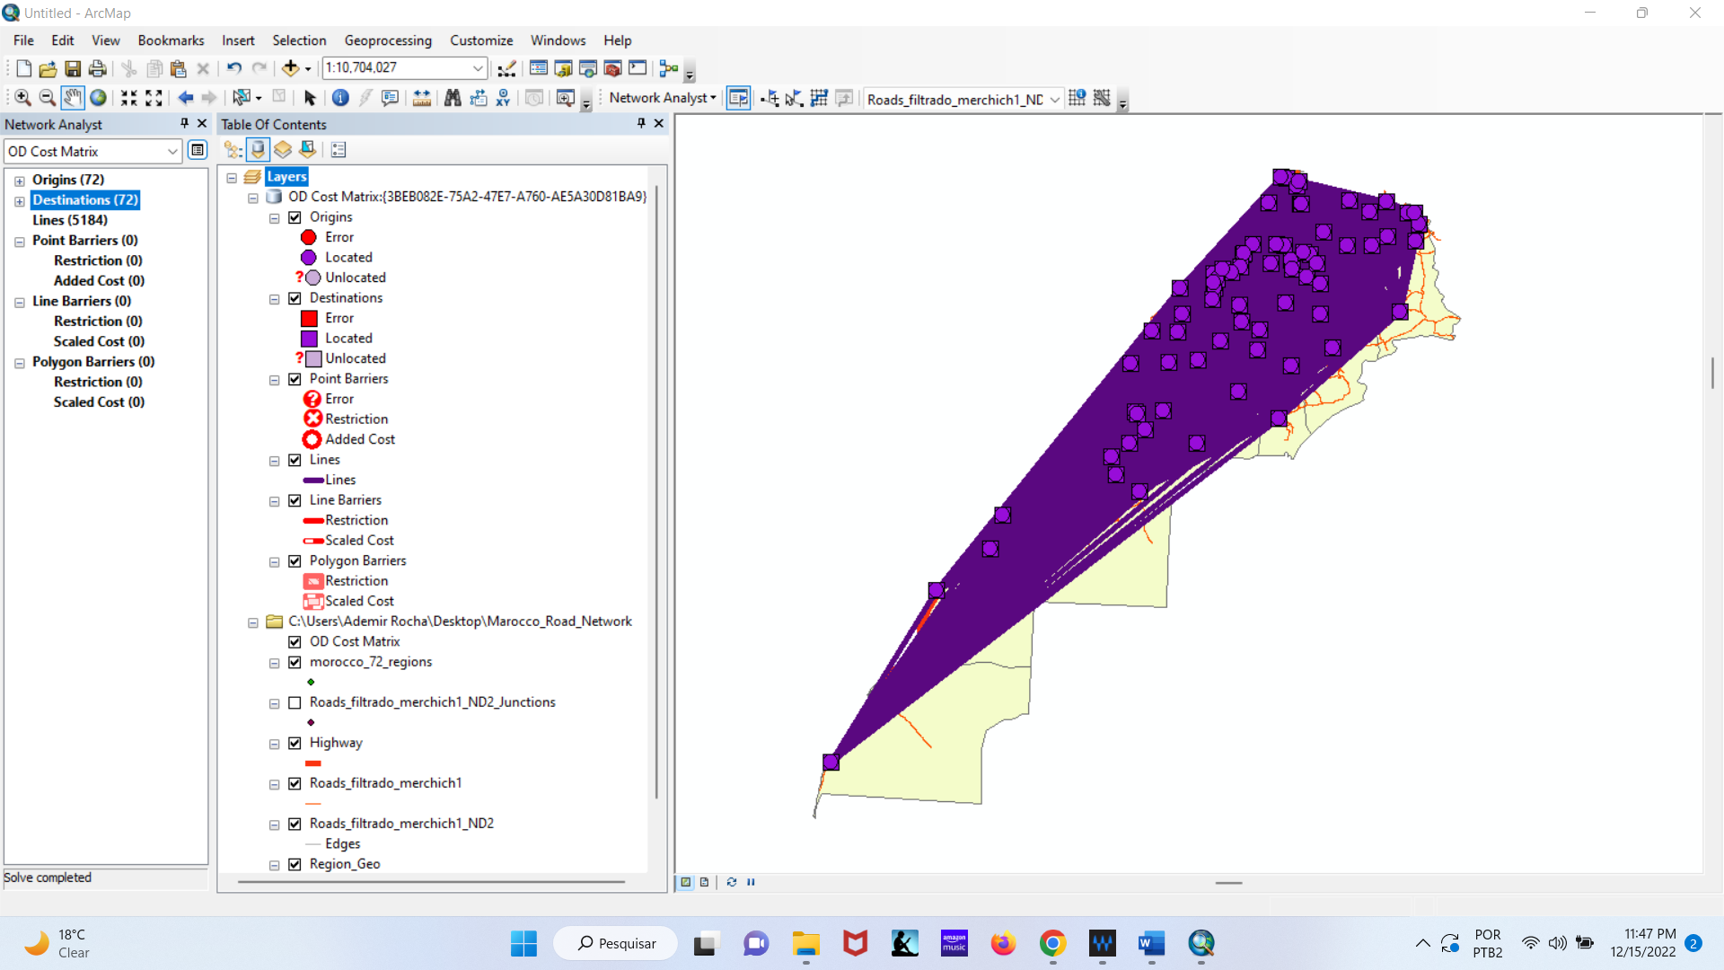

Step 8: Open the lines table using the right mouse button.

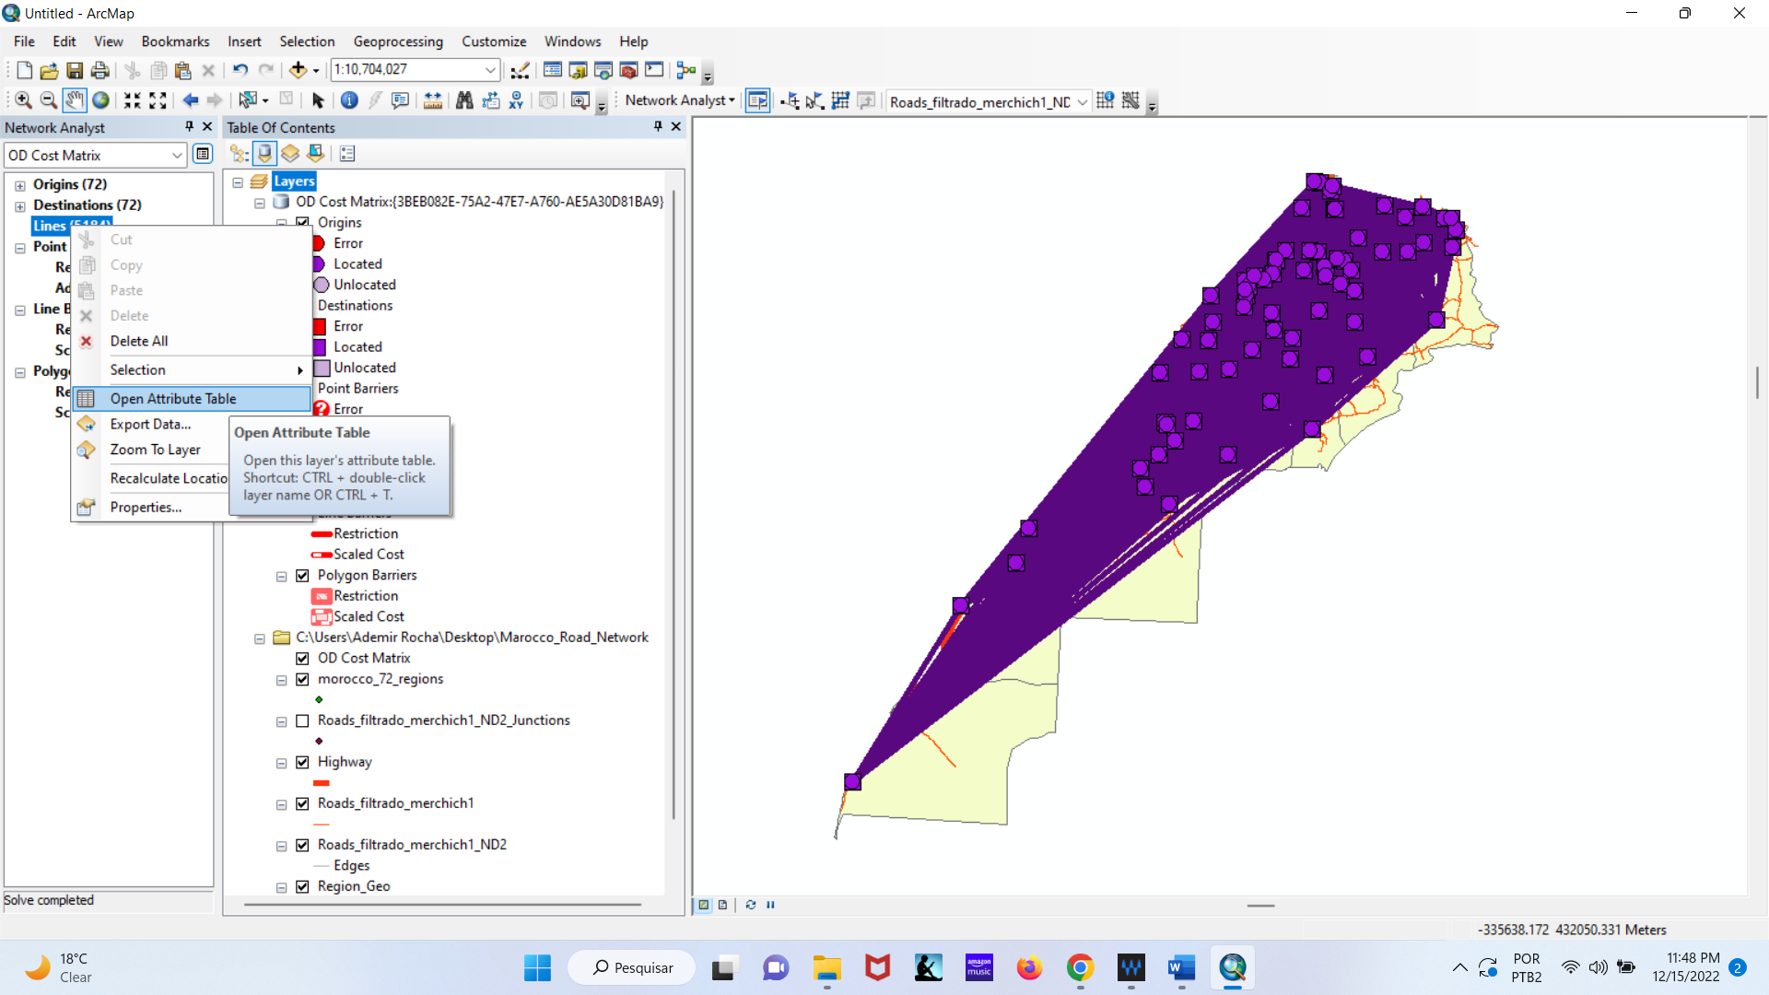

The attribute table is displayed at the bottom of ArcMap.

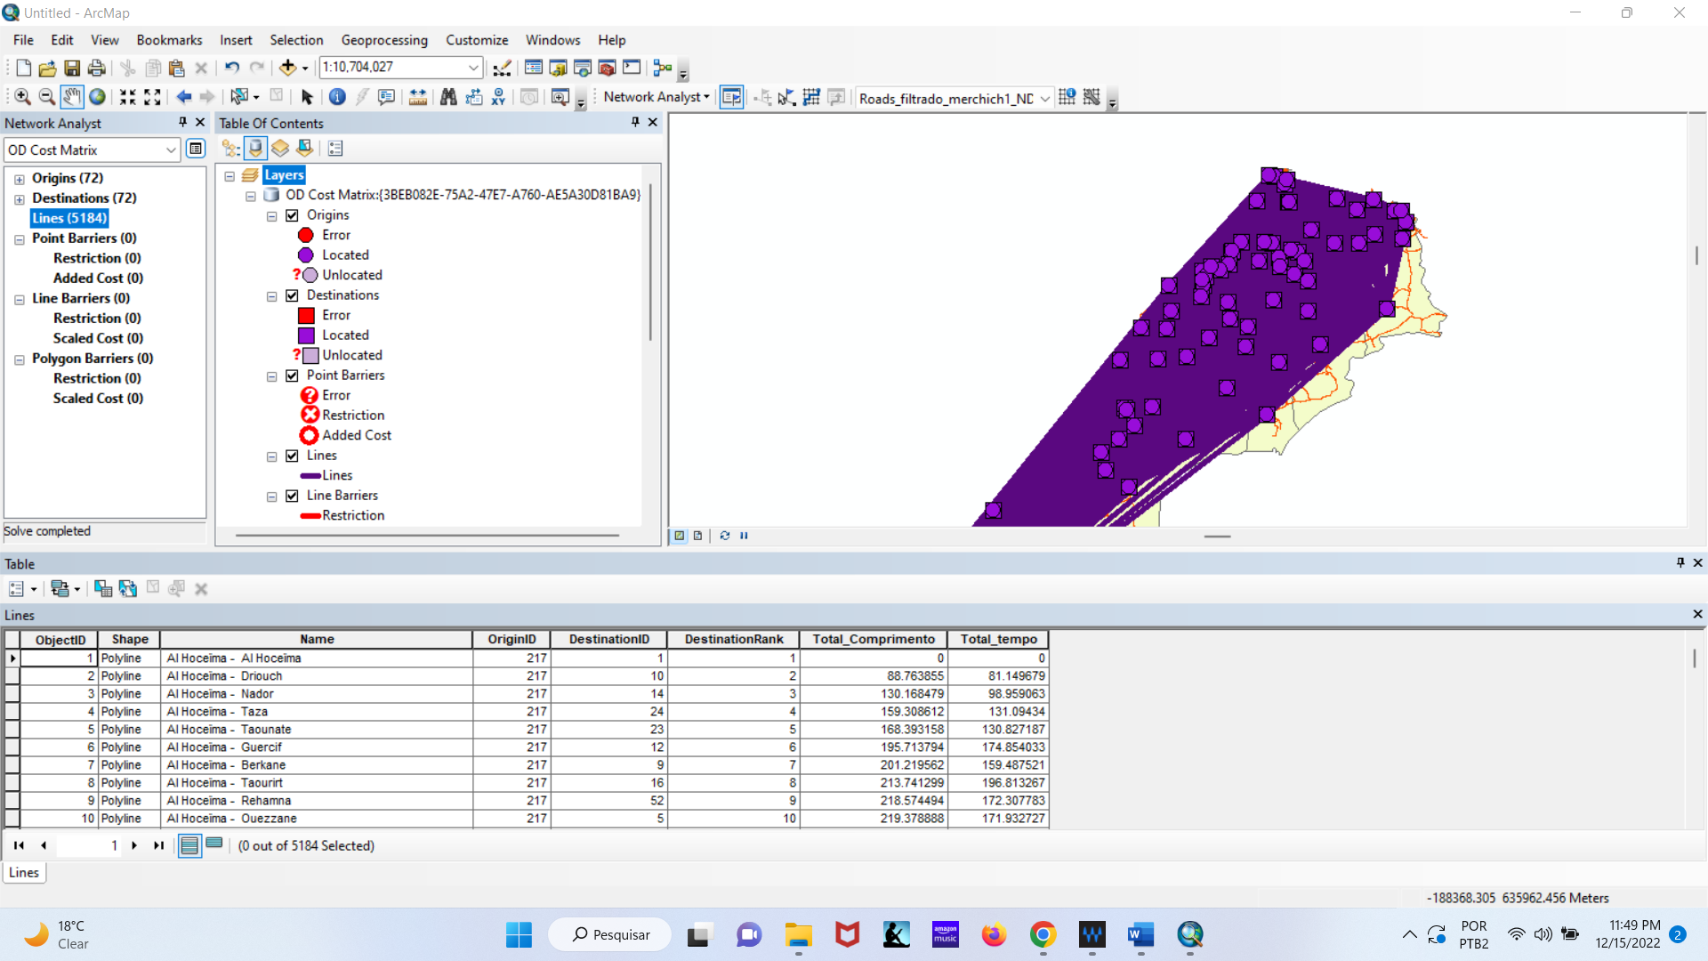

Step 9: To export the OD matrix in .txt format, just follow the next steps.

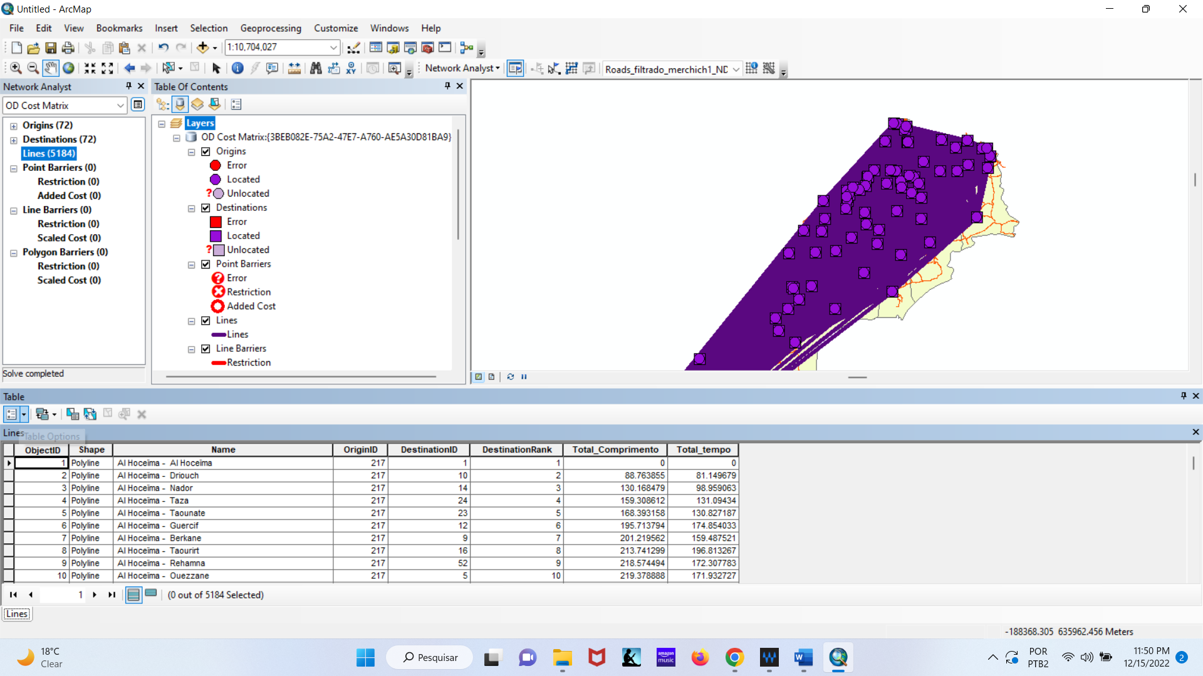

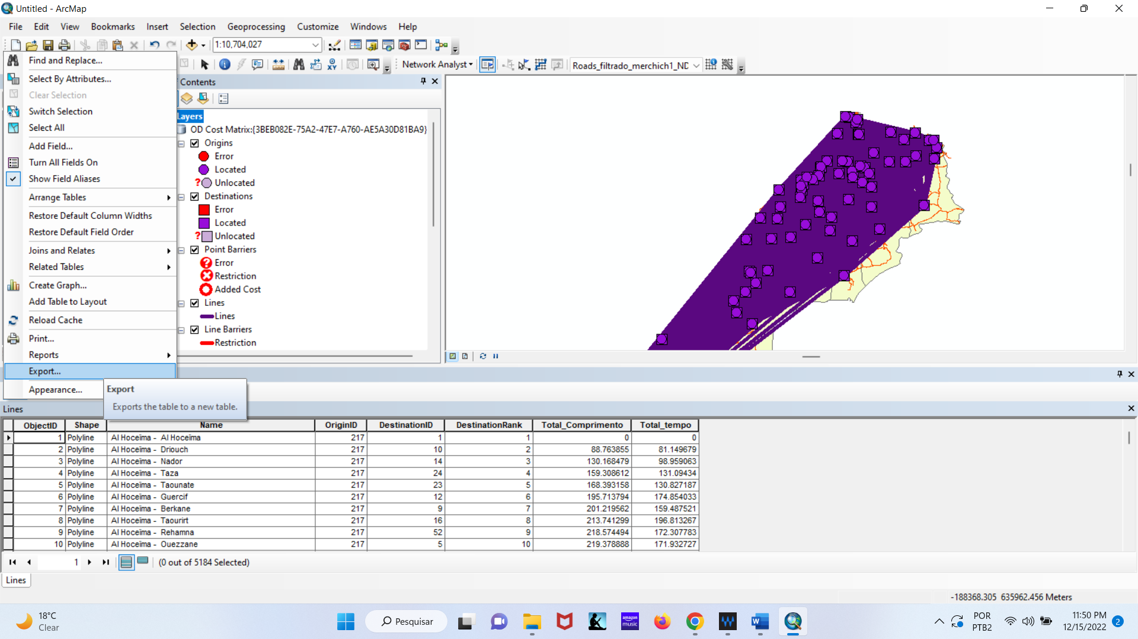

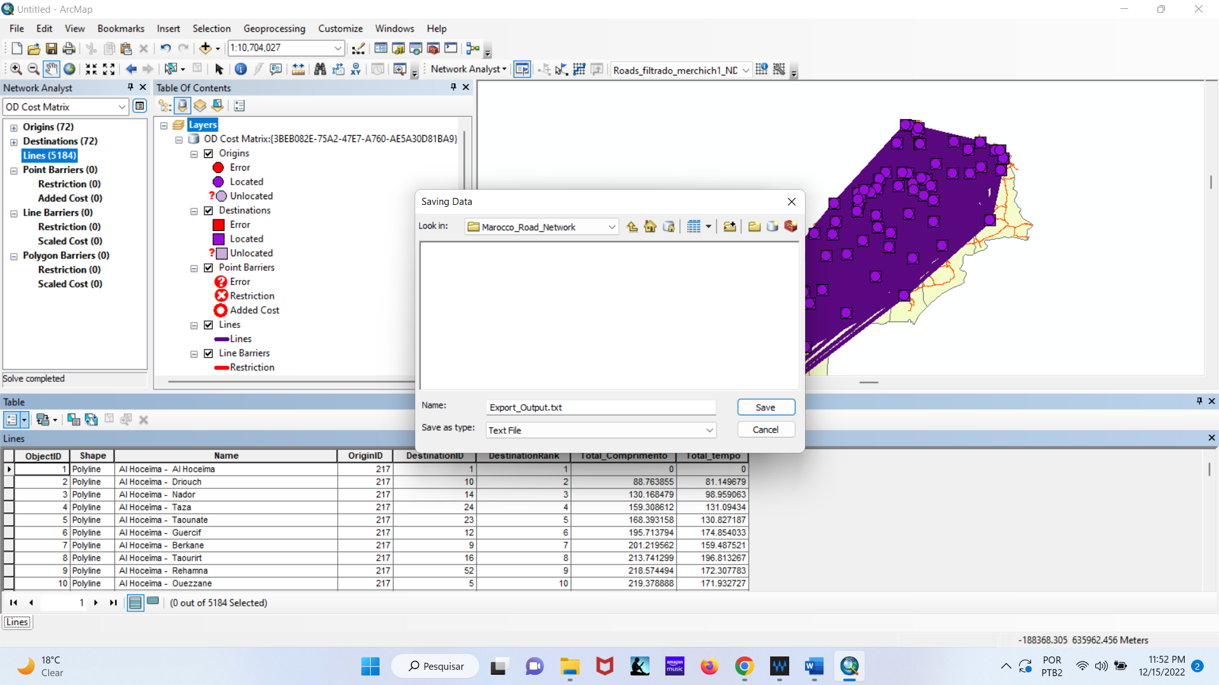

Step 10: It is possible to change the average speed of some parts of the road network (e.g., Tiznit-Dakhla expressway project – see line red on the map). In this case, open the network attributes table and change the maxspeed1 field values.

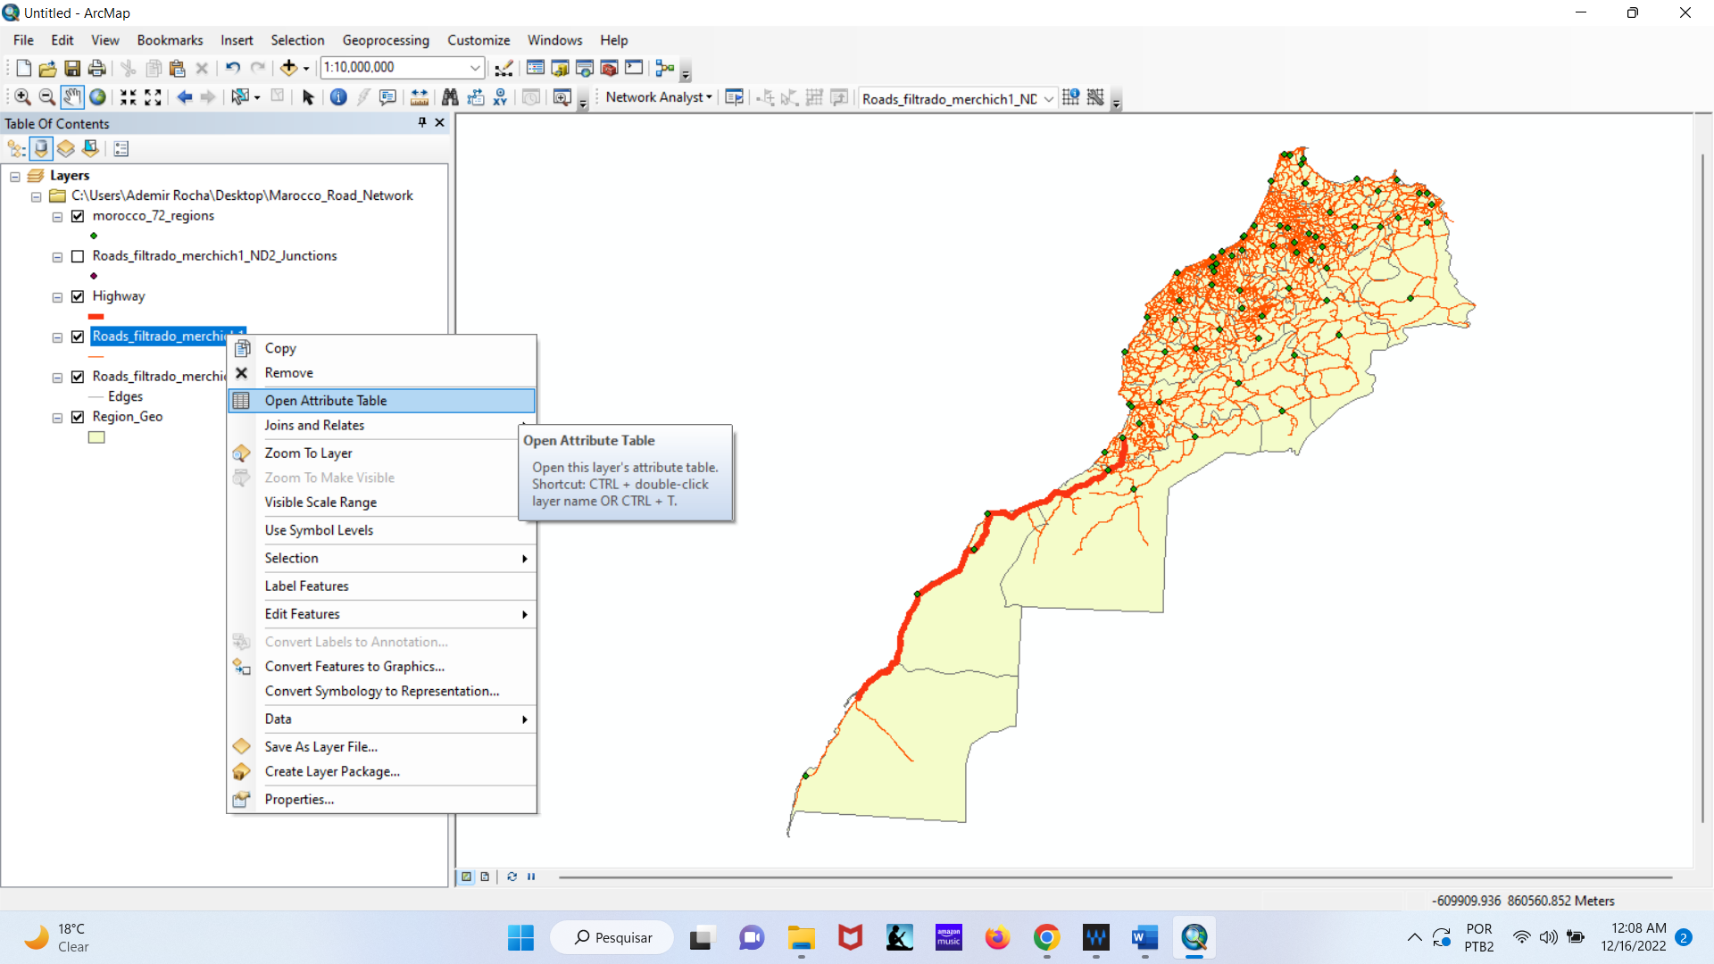

Open the network attributes table and change the maxspeed1 field values. Thus, repeat the procedures to create new OD matrices resulting from these changes in the road network.

